6.2 Exercise Markdown

Felipe Rodriguez

2023-01-19

# Markdown Basics

## Favorite Foods

* Hamburgers
* Pizza
* Tacos

## Images

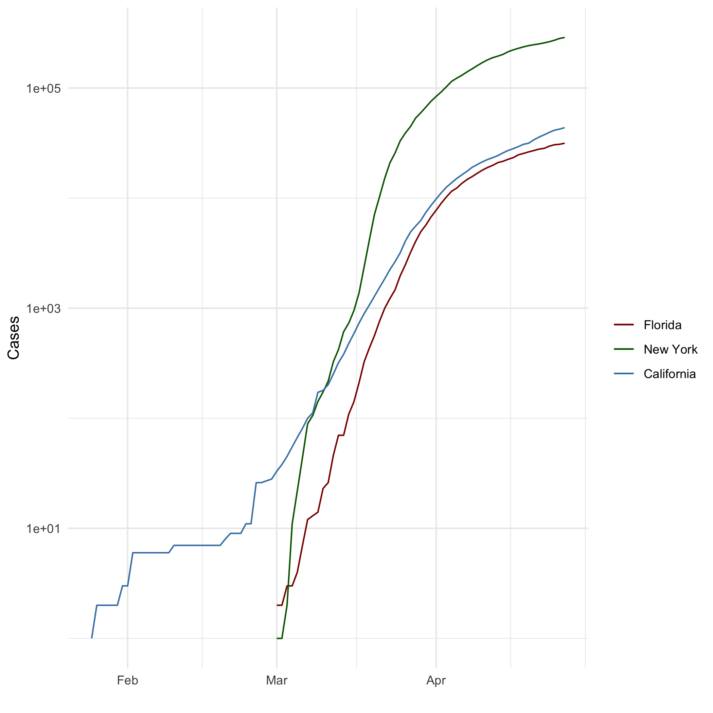

All Cases (Log Plot)

## Add a Quote

“If you tell the truth, you don’t have to remember anything.”

Mark Twain

## Add an Equation

$A=π*r^{2}$

## Add a Footnote

Here is my footnote[1].

## Add Citations

* Field, A., J. Miles, and Z. Field. 2012.Discovering Statistics Using r. SAGE Publications. <https://books.google.com/books?id=wd2K2zC3swIC>.

In text citation: Field, Miles, and Field (2012)

* Lander, J. P. 2014.R for Everyone: Advanced Analytics and Graphics. Addison-Wesley Data and AnalyticsSeries. Addison-Wesley. <https://books.google.com/books?id=3eBVAgAAQBAJ.4>

In text citation: Lander (2014)

# Inline Code

## NY Times COVID-19 Data

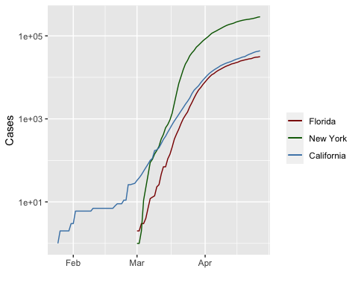

## R4DS Height vs Earnings

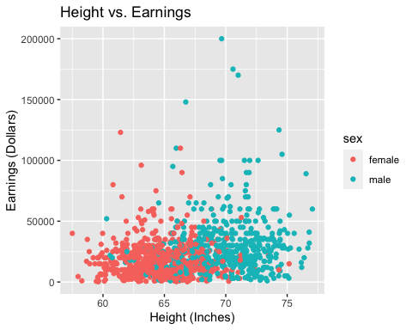

# Tables

## Knitr Table with Kable

One Ring to Rule Them All

| name | race | in_fellowship | ring_bearer | age |
| --- | --- | --- | --- | --- |
| Aragon | Men | TRUE | FALSE | 88 |
| Bilbo | Hobbit | FALSE | TRUE | 129 |
| Frodo | Hobbit | TRUE | TRUE | 51 |
| Galadriel | Elf | FALSE | FALSE | 7000 |
| Sam | Hobbit | TRUE | TRUE | 36 |
| Gandalf | Maia | TRUE | TRUE | 2019 |

## Pandoc Table

| Name | Race | In Fellowship? | Is Ring Bearer? | Age |
| --- | --- | --- | --- | --- |
| Aragon | Men | Yes | No | 88 |
| Bilbo | Hobbit | No | Yes | 129 |
| Frodo | Hobbit | Yes | Yes | 51 |
| Sam | Hobbit | Yes | Yes | 36 |
| Sauron | Maia | No | Yes | 7052 |

# References

Field, A., J. Miles, and Z. Field. 2012. *Discovering Statistics Using r*. SAGE Publications. <https://books.google.com/books?id=wd2K2zC3swIC>.

Lander, J. P. 2014. *R for Everyone: Advanced Analytics and Graphics*. Addison-Wesley Data and Analytics Series. Addison-Wesley. <https://books.google.com/books?id=3eBVAgAAQBAJ>.

1. This is the footnote